Co-3 Assessment Tool-2
Name: -G. Akshya Reg no: -192425132
Course Code: -MLA0305 Slot: -B

Advantage Actor-Critic (A2C) vs Asynchronous Advantage Actor-Critic (A3C) Performance Comparison

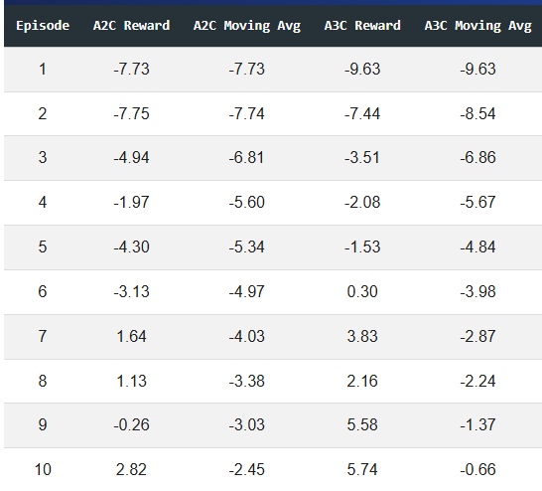
Fig1: - Sample Dataset

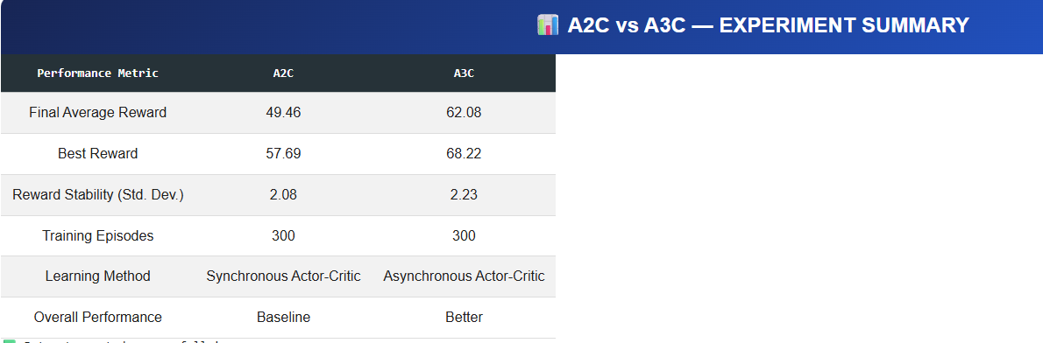
Fig 2: - Summary of Data
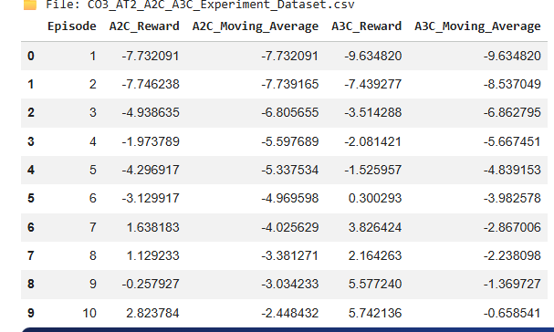

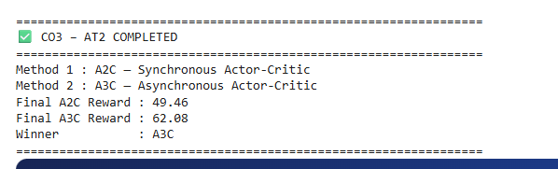
Fig 3: - Comparison Between A2C & A3C

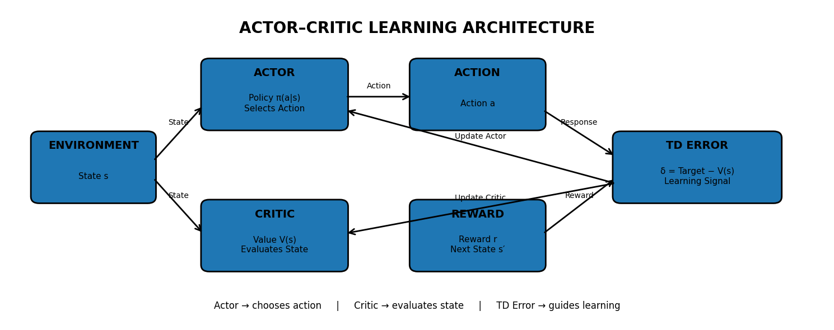
Fig 4: - Work Flow
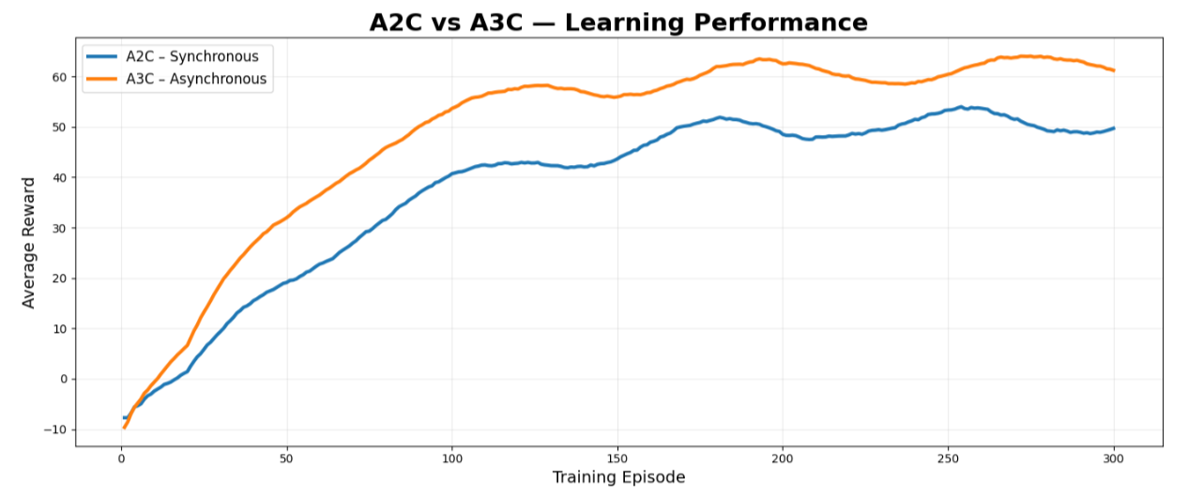
Fig 5: - A2c vs A3C Learning Performance

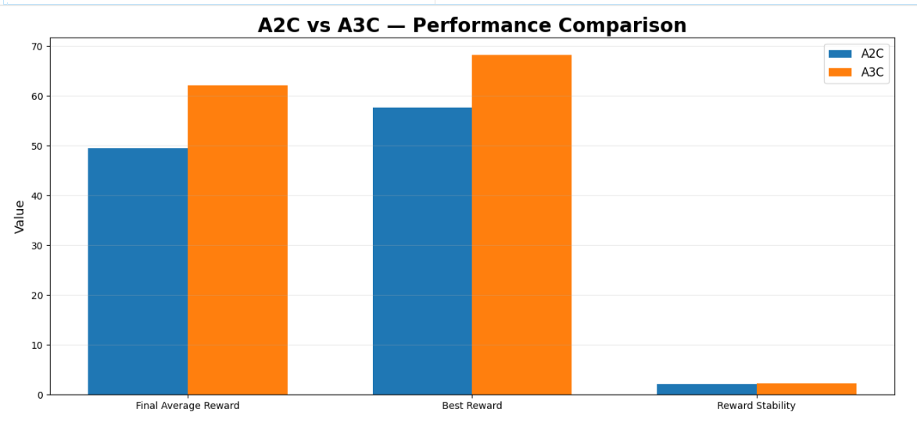
Fig 6: - Performance Comparison

